**VEHICLE TO VEHICLE COMMUNICATION USING LORA**

**OBJECTIVE:**

The objective of this project is to develop a vehicle communication system using Lora technology, integrating sensors for detecting gas, fire, and acceleration. The system aims to provide real-time data transmission from one vehicle to another, enhancing safety and awareness on the road. By employing Internet of Things (IoT) capabilities, the project aims to alert vehicle owners about potential hazards or anomalies detected by the sensors.

**ABSTRACT:**

In today's world, ensuring road safety is paramount. This project introduces a novel approach to vehicle communication utilizing LoRa (Long Range) technology. The system consists of two main components: a transmitter and a receiver. The transmitter incorporates sensors for gas, fire, and acceleration detection, alongside a button for manual status indication. Upon sensing an anomaly, data is transmitted via LoRa to the receiver unit. The receiver, equipped with an LCD display and a buzzer, promptly alerts the vehicle owner. Through this setup, critical information about the vehicle's surroundings can be efficiently communicated, aiding in accident prevention and overall road safety.

**INTRODUCTION:**

The integration of advanced technologies in the automotive sector has significantly contributed to enhancing safety standards. In line with this trend, our project proposes the implementation of a vehicle communication system utilizing LoRa technology. LoRa, known for its long-range and low-power characteristics, offers an ideal solution for transmitting data between vehicles in real-time, overcoming the limitations of traditional communication methods.

The project comprises two interconnected modules: the transmitter and the receiver. The transmitter module is responsible for collecting data from sensors monitoring gas, fire, and acceleration levels. Additionally, a manual status indication button allows users to convey their vehicle's condition instantly. Upon detection of an anomaly, the transmitter transmits this data using Lora communication to the receiver unit.

On the receiving end, the receiver module decodes the transmitted data and displays it on an LCD screen. Simultaneously, an audible alert, generated by a buzzer, notifies the vehicle owner of the detected anomaly. This seamless communication loop ensures prompt awareness and action, enabling vehicle operators to respond effectively to potential hazards.

Through the integration of IoT capabilities, our system goes beyond simple sensor data transmission, enabling remote monitoring and alerting. By providing timely and accurate information about the vehicle's surroundings, the project aims to enhance road safety and contribute to the realization of a smarter, safer automotive ecosystem.

**EXISTING SYSTEM:**

Vehicle communication systems lacked efficient long-range transmission capabilities and comprehensive sensor integration. Traditional systems primarily relied on short-range technologies like Bluetooth or Wi-Fi, limiting their effectiveness in transmitting data between vehicles. Sensor integration was also minimal, often focusing on basic functions like collision detection. Moreover, IoT capabilities were not extensively utilized for real-time monitoring and alerting. Overall, the existing systems lacked the robustness and flexibility required to provide comprehensive vehicle-to-vehicle communication for enhancing road safety.

**DISADVANTAGES:**

1. Limited Range
2. Interference Issues
3. Data Security Concerns
4. High Power Consumption
5. Limited Sensor Integration
6. Lack of Real-time Monitoring
7. Complexity and Cost

**PROPOSED SYSTEM:**

The proposed system introduces a vehicle communication solution leveraging LoRa technology, offering extended range transmission and low-power consumption. Integrated sensors for gas, fire, and acceleration detection enhance safety monitoring capabilities, while a manual status indication button provides additional context. Utilizing IoT functionalities, the system enables real-time data transmission to a receiver unit, equipped with an LCD display and buzzer for immediate alerts. By combining LoRa's advantages with comprehensive sensor integration and IoT capabilities, the proposed system aims to revolutionize vehicle-to-vehicle communication, fostering enhanced road safety and awareness.

**ADVANTAGES:**

1. Extended Range Transmission
2. Low Power Consumption
3. Comprehensive Sensor Integration
4. Real-time Monitoring and Alerting
5. Manual Status Indication
6. Cost-effectiveness
7. Scalability and Flexibility

**BLOCK DIAGRAM (HARDWARE):**

TRANSMITTER PART:

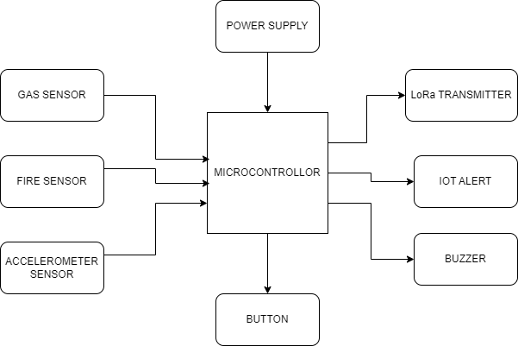

RECEIVER PART:

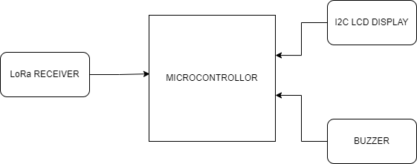

**BLOCK DIAGRAM DESCRIPTION:**

The block diagram for the proposed vehicle communication system consists of two main sections: the transmitter and the receiver. The transmitter section includes gas, fire, and accelerometer sensors, along with a manual status indication button. Data from these sensors is processed by a microcontroller and transmitted via a LoRa transmitter. The receiver section comprises a LoRa receiver, which receives the transmitted data and forwards it to another microcontroller. An LCD display and a buzzer are connected to the receiver microcontroller to provide real-time alerts to the vehicle owner. This modular setup ensures efficient data transmission and immediate response to detected anomalies, enhancing overall road safety.

**SOFTWARE REQUIREMENTS:**

* Arduino ide
* Embedded C
* IOT

**HARDWARE REQUIREMENTS:**

* Microcontroller
* Gas sensor
* Fire sensor
* Accelerometer sensor
* LoRa Transmitter
* LoRa Receiver
* I2C LCD
* Button
* Buzzer

**CONCLUSION:**

In conclusion, the implementation of a vehicle communication system utilizing LoRa technology offers a significant advancement in enhancing road safety and awareness. By integrating comprehensive sensor arrays, real-time monitoring, and immediate alerting capabilities, the proposed system provides a robust solution for detecting and mitigating potential hazards on the road. The combination of extended range transmission, low-power consumption, and cost-effectiveness ensures scalability and accessibility across various vehicle types and applications. With its ability to facilitate timely communication between vehicles and enable prompt responses to critical situations, this project marks a significant step towards realizing a smarter and safer automotive ecosystem.